Test backup and add datastore Proxmox Backup Server from Proxmox VE

- Login to Proxmox Backup Server, then create Add Datastore
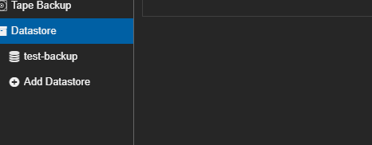
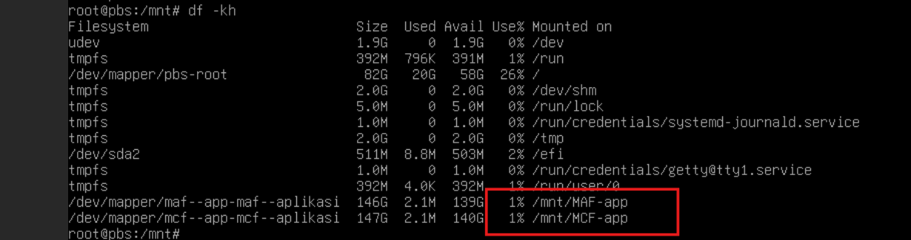
- Fill the name, Datastore Type and Backing Path(sesuai pada mountpoint yang ada dari gambar sebelumnya). And
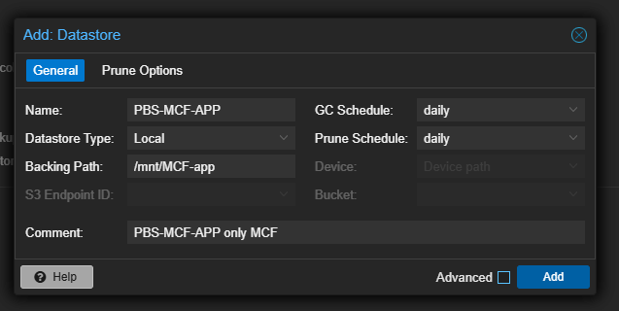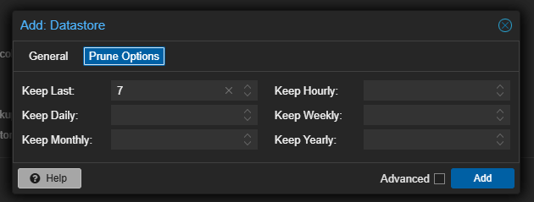
- Create Namespace for separate application and database
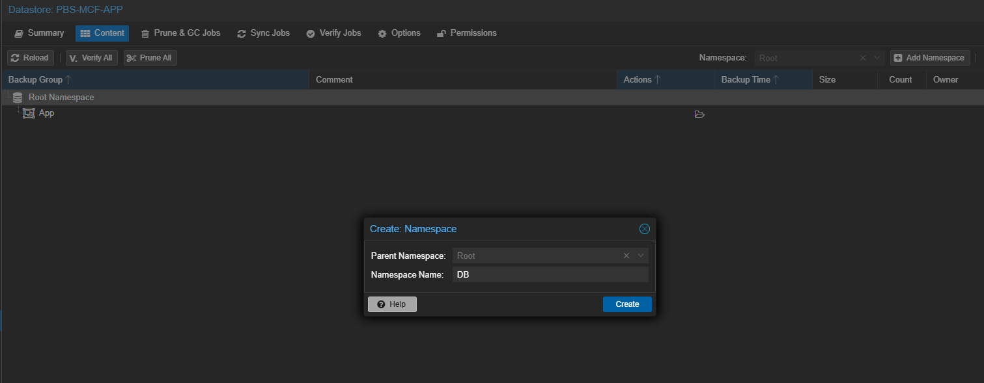
- Add User permission using Proxmox Backup Server such as usradmsvr, prevent using root@pam because this role is superadmin.
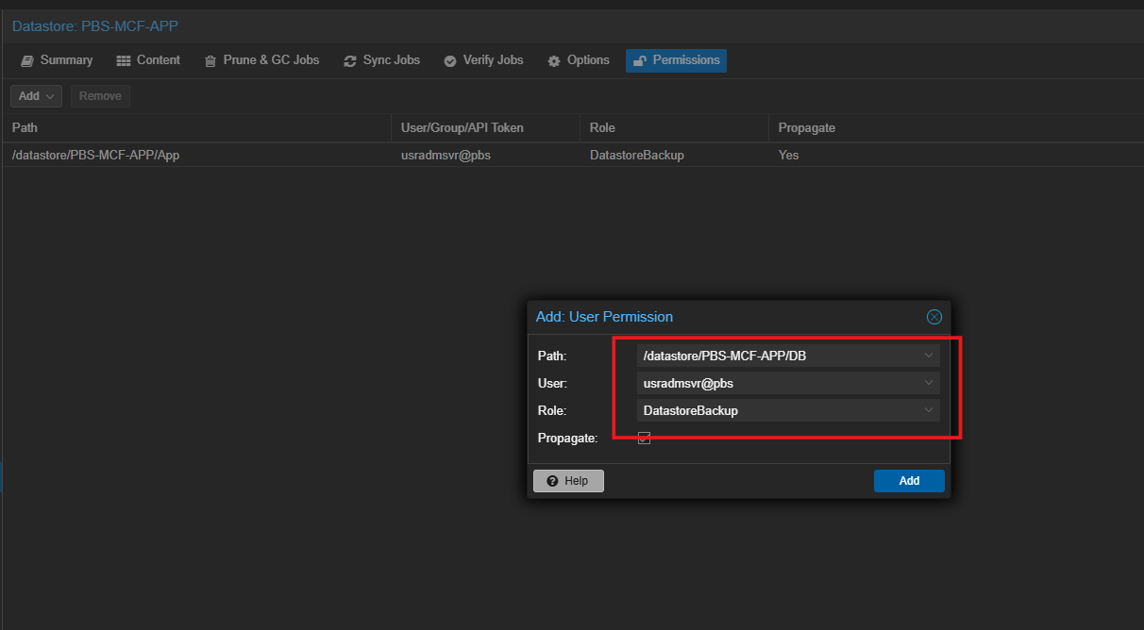
- Login to Proxmox VE, then add Storage using type Proxmox Backup Server
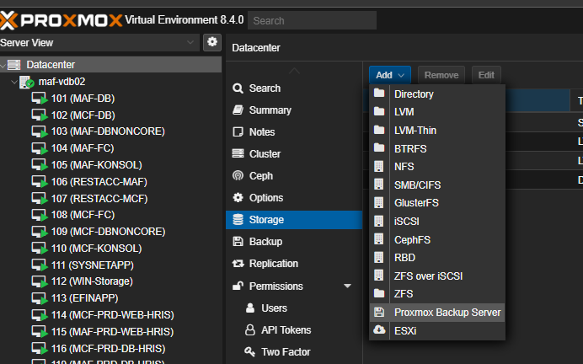
- Fill the credential Fingerprint from PBS connection information, and make sure you always fill the namespace App for Application Server, DB for Database Server
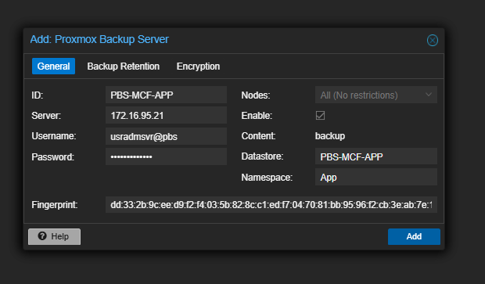
*PBS Connection Information
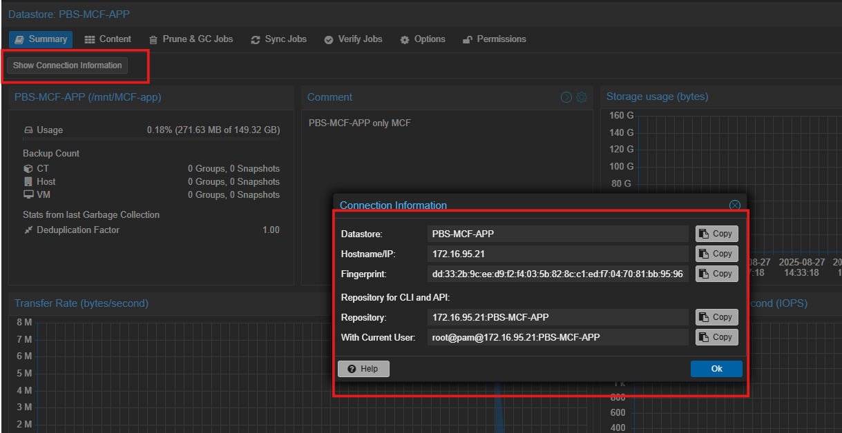
- Repeat the step 6 for namespace Database
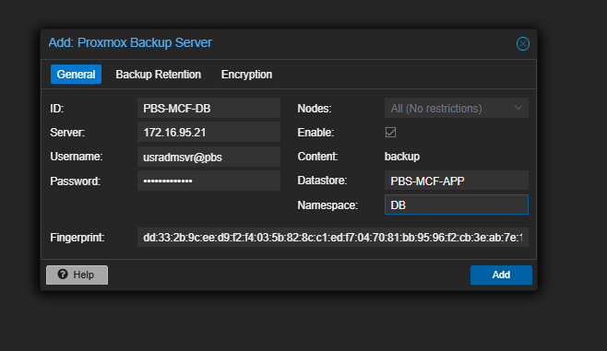
- Login Proxmox VE and then test backup now from Application Server, make sure that Storage mapping to APP for only Application Server
